Weekly Assessment for Delta Operations on ESA and CESA-listed Salmonids including Current Delta Hydrologic Conditions
  - Last updated: Monday, March 09, 2026 at 8 AM
Table of contents

Executive Summary
- Entrainment management season is active.
- Annual Loss: 4 (0.03% of annual loss threshold) natural winter-run, 0 (0.00% of annual loss threshold) hatchery winter-run, 182 natural steelhead, 986 (16.14% of annual loss threshold) hatchery steelhead, and 1058 (48.12% of annual loss threshold) spring-run surrogates.
- Single-year Incidental Take Limit (ITL) Status: 4 (0.07% of 5,922 ITL) natural winter-run; 0 (0.00% of 1,301 ITL) hatchery winter-run; 182 (3.44% of 5,294 ITL) natural steelhead.
- Spring-run surrogate yearlings (0.5% ITL per experimental release group): Group 1: 0 (0% of 376 ITL); Group 2: 257 (84.64% of 304 ITL); Group 3: 35 (12.26% of 286 ITL).
- LAD winter-run presence in the Delta is high based on historical monitoring.
- Steelhead presence in the Delta is high based on historical monitoring.

1 Current Delta Hydrologic Conditions

1.1 Operational and Regulatory Conditions
The current controlling factor is OMRI restrictions to no more negative than -5,000 cfs. See most recent weekly outlook for more information.

1.2 Current Conditions
Most recent inflow at Freeport in the Sacramento River and Vernalis in the San Joaquin River is 37,997 and 5,351 cfs respectively. Most recent Jersey Point Flow (JPF) is 6,075 cfs. Most recent 1-day, 5-day, and 14-day OMRI measurements were -4,951, -4,950, and -5,061 cfs, respectively, and most recent export data were 3,551 cfs for Jones Pumping Plant and 1,734 cfs for Henry O. Banks Pumping Plant.
Figure 1: Operations and Action Summary, WY 2026. The numbers and lines in the OMRI plot indicate different triggers and thresholds (see Table 1), with shading representing specific action periods. Dashed and dotted vertical lines represent triggered actions and thresholds, respectively. OMRI data (colored lines) calculated by SacPAS, Freeport (FPT) and Vernalis (VNS) flow data from CDEC, Jersey Point Flow (JPF) from DWR, and CVP (TRP) and SWP (HRO) exports data from CDEC.
Table 1: Summary of Actions and Triggers, WY 2026
Label | Action | Date Triggered | Date Implemented | Number Days Implemented | Regulation
1 | DCC Gate Closure | 10/28/2025 | 2025-10-30 | Ongoing | DCC gates
2 | First Flush | 12/24/2025 | 2025-12-25 | 14 days | Entrainment Management
3 | Offramp temperature threshold | 2/12/2026 |  | 3 consecutive days | Delta Smelt Adult Entrainment, no action taken WY26

1.3 Zone of Influence
Zone of Influence (ZOI) analysis is discussed in detail in the December 22 assessment. Current conditions were queried from most recent Freeport flow data on the Sacramento River and Vernalis flow data on the San Joaquin river from SacPAS. Forecasted flows were queried from short range deterministic flows provided by the California Nevada River Forecast Center.
Current conditions at Freeport and Vernalis indicate that delta hydrology falls within the ‘hihi’ category. Forecasted conditions averaged across the next 7 days falls within the ‘hihi’ category.
The altered channel length for the current “hihi” hydrology is 99, 100, 119 and 114 kilometers (km) across OMR bins of -2000, -3500, -5000 and <-5500 respectively. The altered channel length for forecasted “hihi” hydrology is 99, 100, 119 and 114 kilometers (km) across OMR bins of -2000, -3500, -5000 and <-5500 respectively.
Change in altered channel length between OMR levels is 15 km for current conditions and 15 km for forecasted conditions indicating that ZOI impacts across OMR scenarios would not change between current and forecasted conditions. Across the nine hydrology bins, changes in altered channel length across OMR scenarios are low (<25th percentile) for both current and forecasted hydrology.
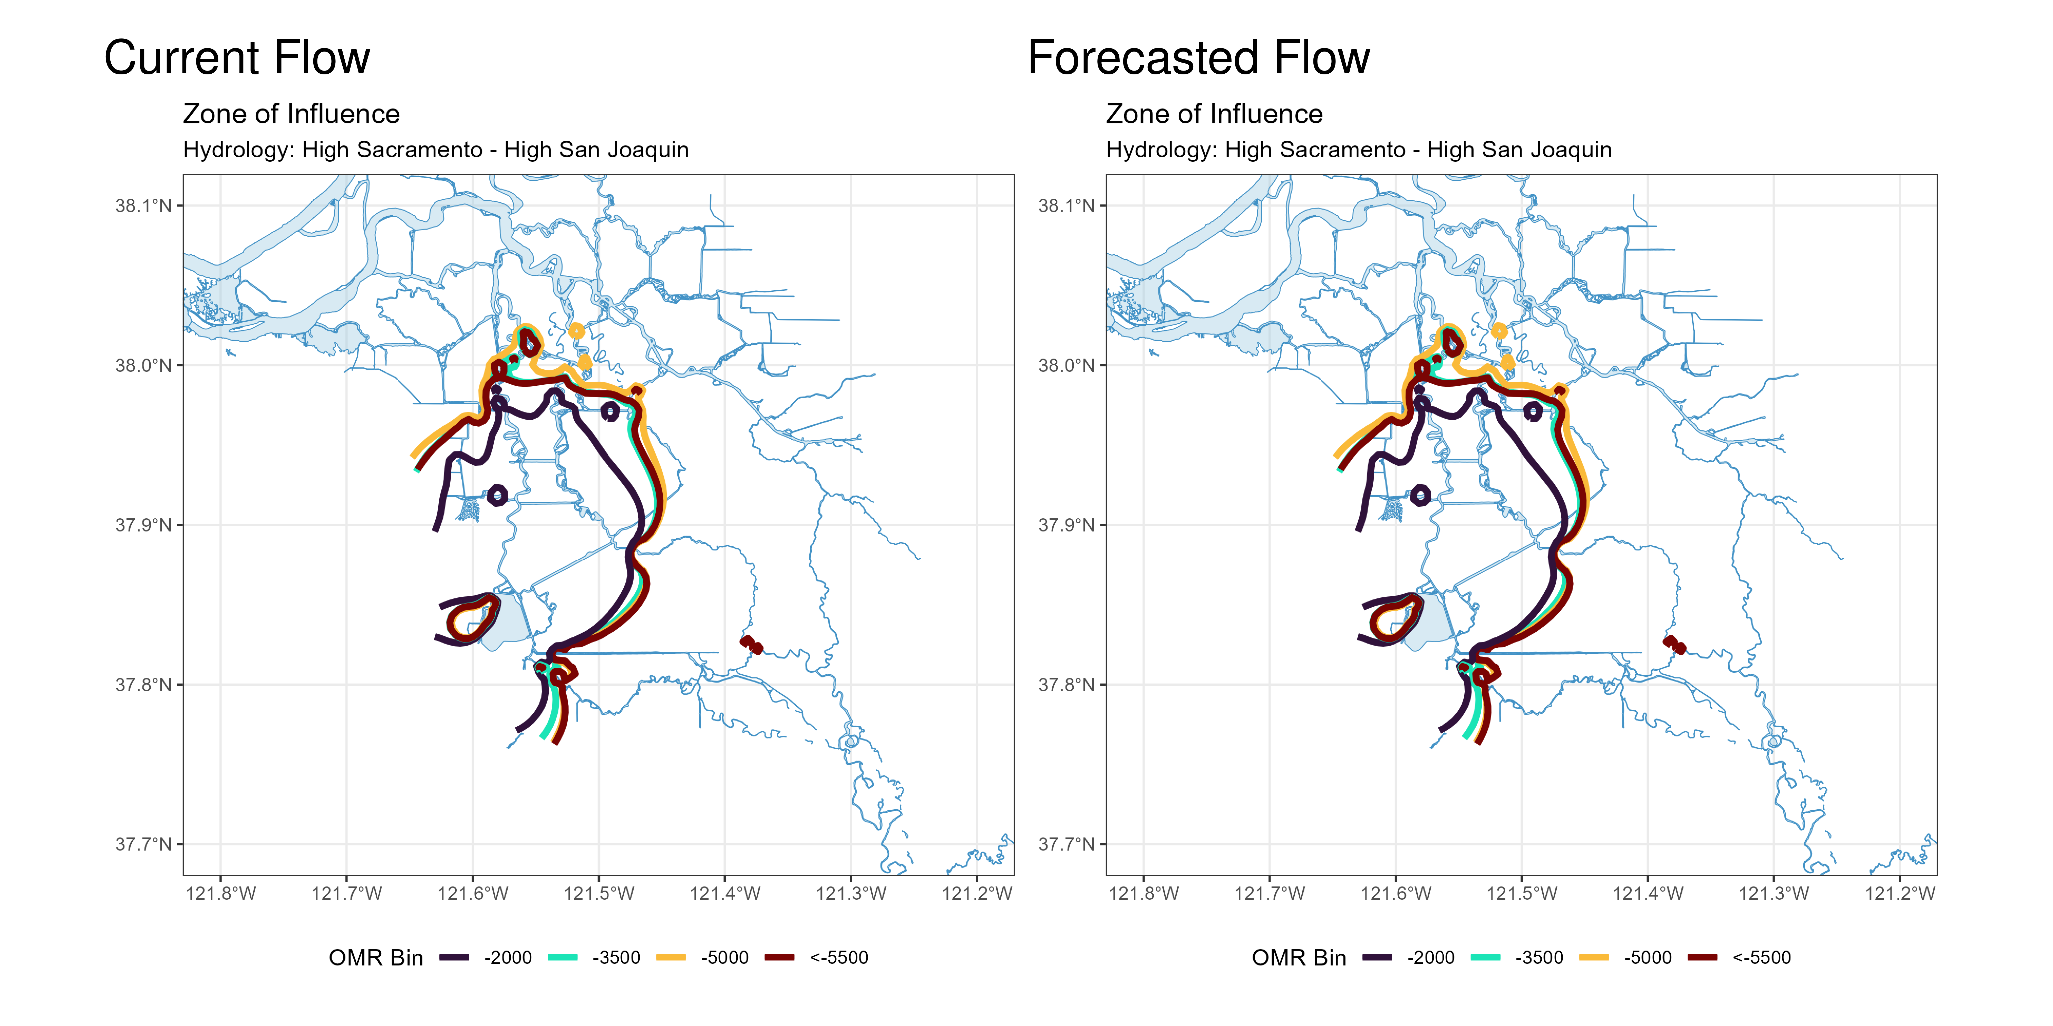
Figure 2: Modeled Zone of Influence at different OMRI scenarios based on current inflow hydrology (left) and forecasted inflow hydrology (right) from the Sacramento River and San Joaquin River

2 Assessment for Delta Operations on Salmonids
For more detailed data on salmonid conditions in the Delta see corresponding webpage on SacPAS.

2.1 Natural Winter-run Chinook

2.1.1 Juvenile Production Estimate
The Juvenile Production Estimate for winter-run is 1,057,452 for the current water year.

2.1.2 Current Status
Delta Entry Timing - Historically, as of Mar 08, 60% of length-at-date (LAD) winter-run have entered the Delta based on Knights Landing RST catch, 17% have exited the Delta based on Chipps Island Trawl Catch, and 66% of DNA confirmed winter-run have been salvaged.
Table 2: Average percent of annual emigrating population for unclipped LAD winter-run captured at monitoring locations and salvaged at Delta facilities for the past 10 years.
Species | Red Bluff Diversion Dam | Tisdale RST | Knights Landing RST | Sac Trawl (Sherwood) | Chipps Island Trawl | Salvage
Chinook, LAD Winter-run, Unclipped | 99% | 98% | 98% | 60% | 17% | 55%
Chinook, DNA Winter-run, Unclipped (Water Year) |  |  |  |  |  | 66%
Red Bluff Diversion Dam Passage Estimate - As of Mar 04 estimated passage to date of LAD winter-run at Red Bluff Diversion is approximately 4.17 million fish. Note that outmigration timing overlaps with spring-run migrating fish, and true winter-run abundance likely differs from these estimates.
Delta Monitoring - Total catch of LAD winter-run at RSTs at Delta Entry (Tisdale, Knights Landing, Lower Sacramento River) between Feb 22 and Mar 05 is 11 individuals. Total catch at Sacramento Trawl and Beach Seines in the delta between Feb 23 and Mar 05 is 36 individuals. Total catch at Delta Exit at Chipps Island between Feb 23 and Mar 05 is 26 individuals.

2.1.3 Annual Loss
The annual loss threshold for natural winter-run is 1% of the JPE or 10,575 fish. The single-year incidental take limit (ITL) is 0.56% of the JPE (5,922 fish) or 0.36% on a 3-year rolling average (BiOp Table 184). As of March 08, cumulative loss of genetically confirmed winter-run is 4 or 0.03% of the annual loss threshold. Cumulative loss in the past 7 days has been 0.
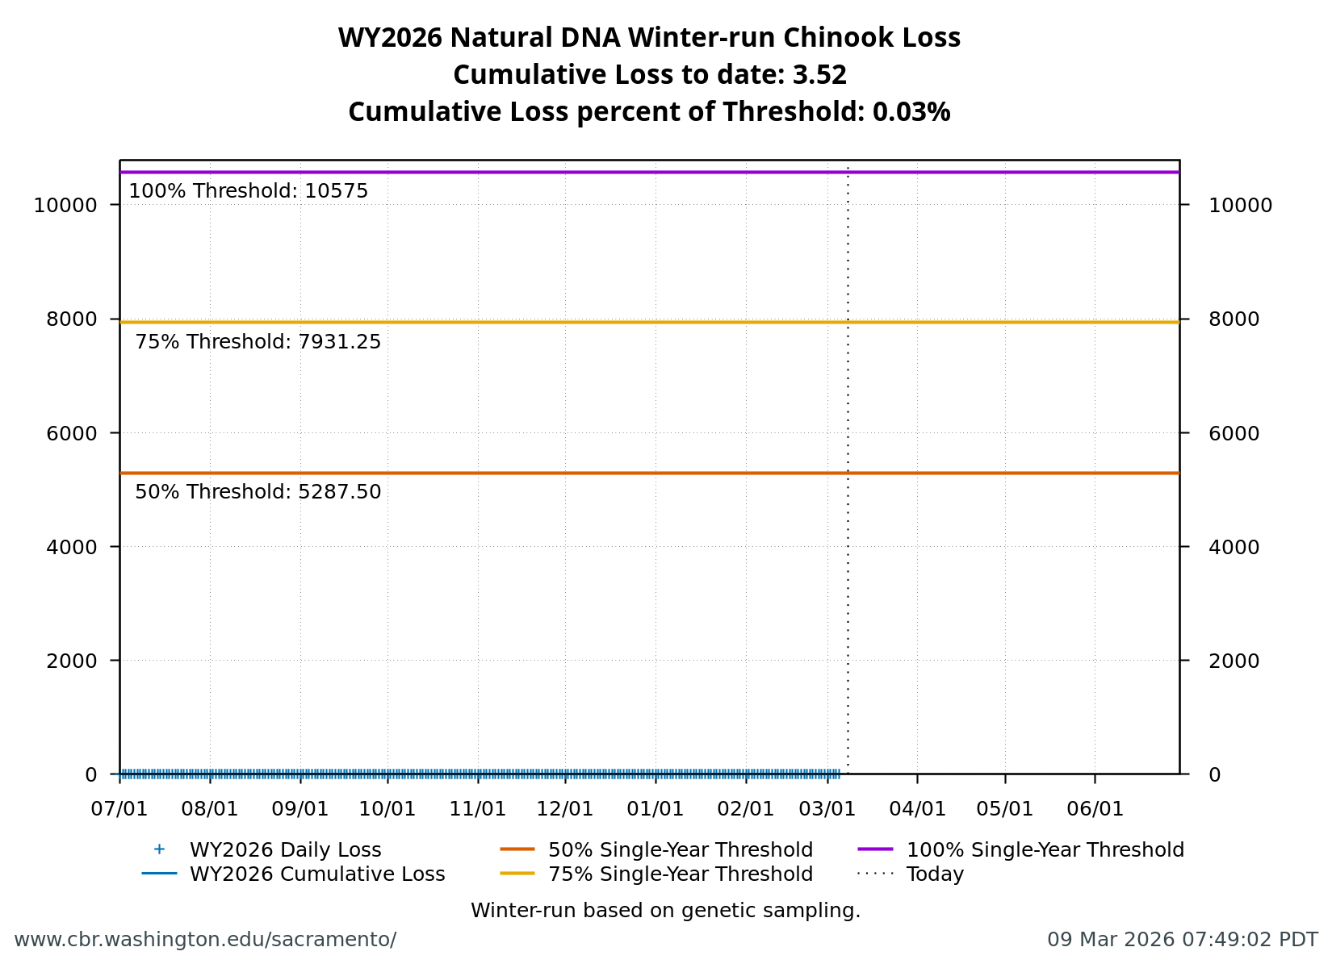
Figure 3: Cumulative loss of natural-origin winter-run for WY 2026. Cumulative loss is based on genetically confirmed winter-run captured in salvage or length-at-date winter-run in which genetic confirmation was unable to be obtained.

2.1.4 STARS
The Delta STARS Model is an individual-based simulation model that predicts survival, travel time, and routing of juvenile salmon migrating through the Sacramento–San Joaquin River Delta. This model gives insight into survival and routing patterns of winter-run based on most current conditions.
As of March 07, overall through delta STARS estimated survival probability (with 80% credible intervals) is 0.61 (0.57-0.65) placing it in the 50th percentile of historical STARS survival estimates for the month of March (WYs 2018-2025). STARS estimated routing and survival probabilities (with 80% credible intervals) into the interior delta are 0.12 (0.1-0.13) and 0.37 (0.28-0.46), respectively, corresponding to the 48th and 50th percentiles of historical March estimates (WYs 2018-2025).
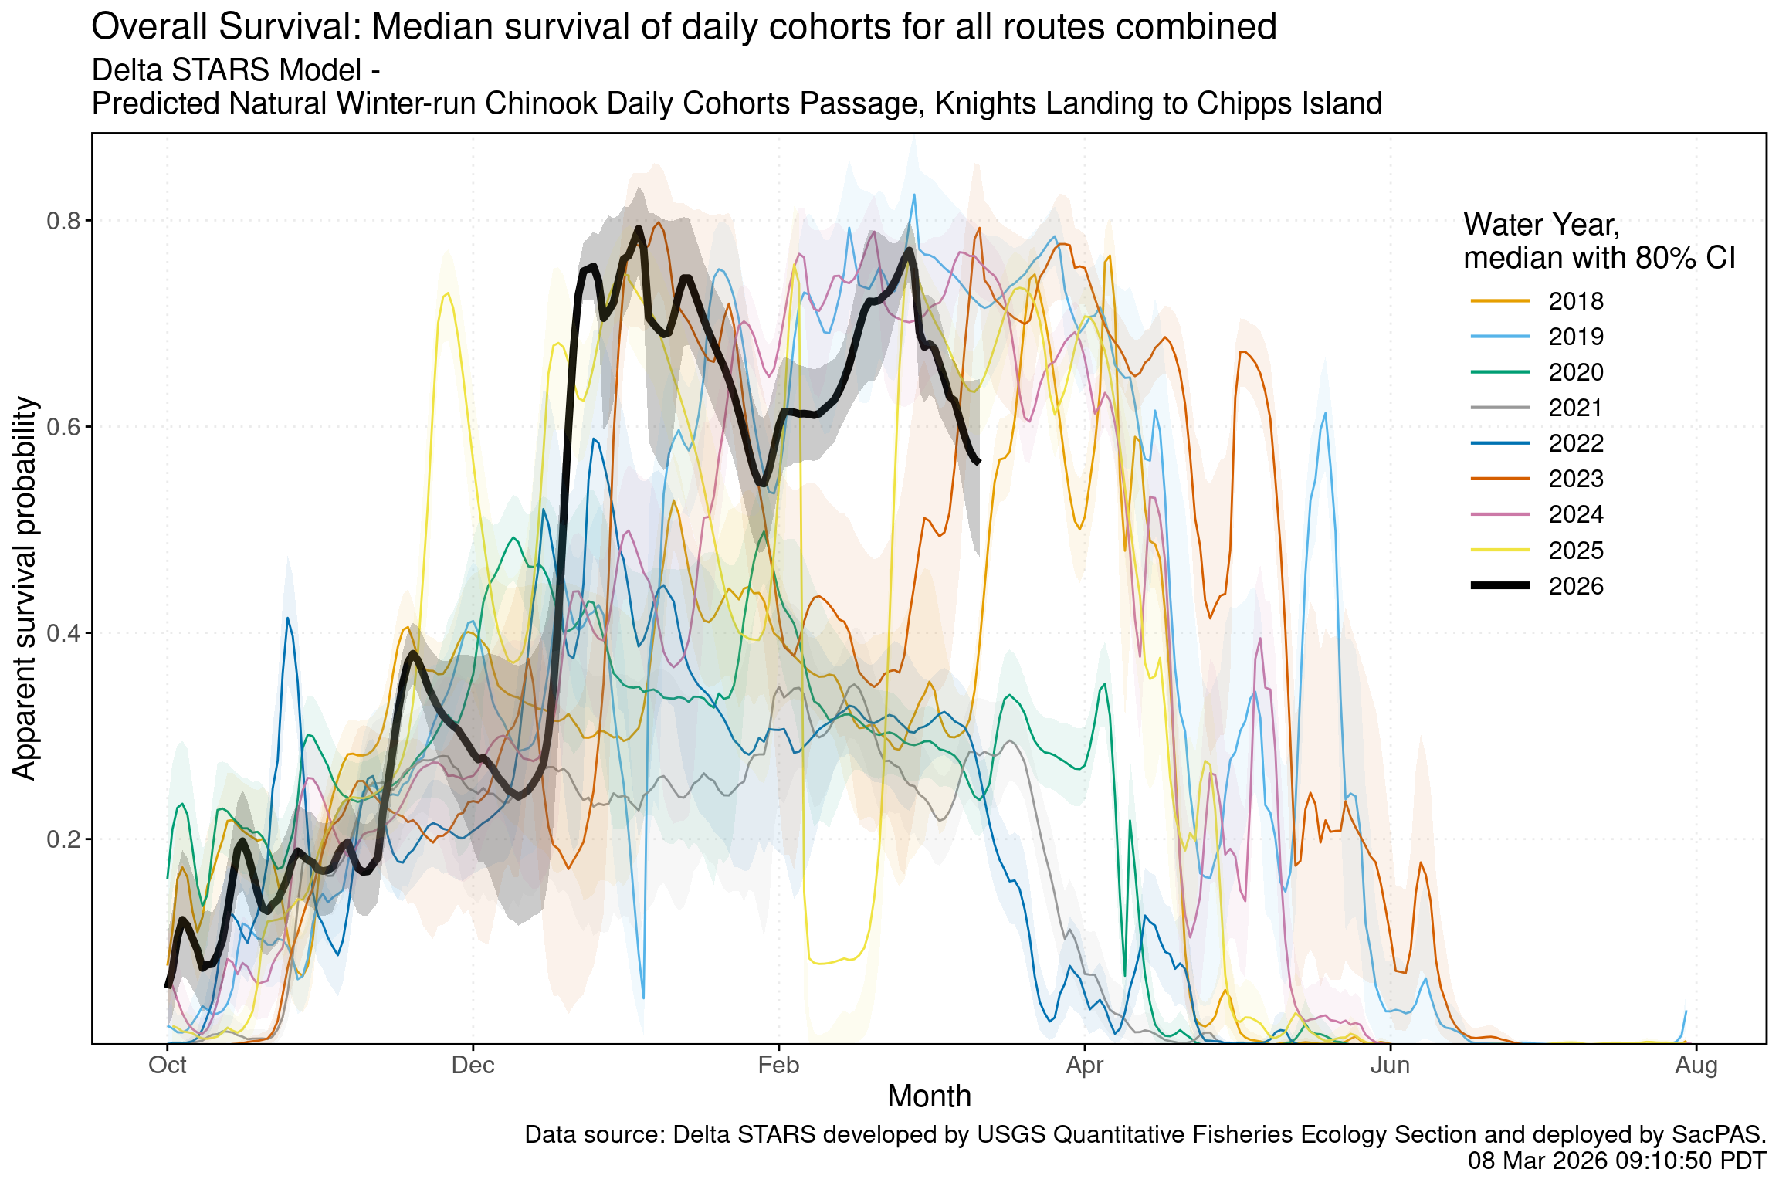
Figure 4: Estimated overall winter-run survival from Knights Landing to Chipps Island. Black line indicates the current water-year, and other colored lines correspond to past water years.
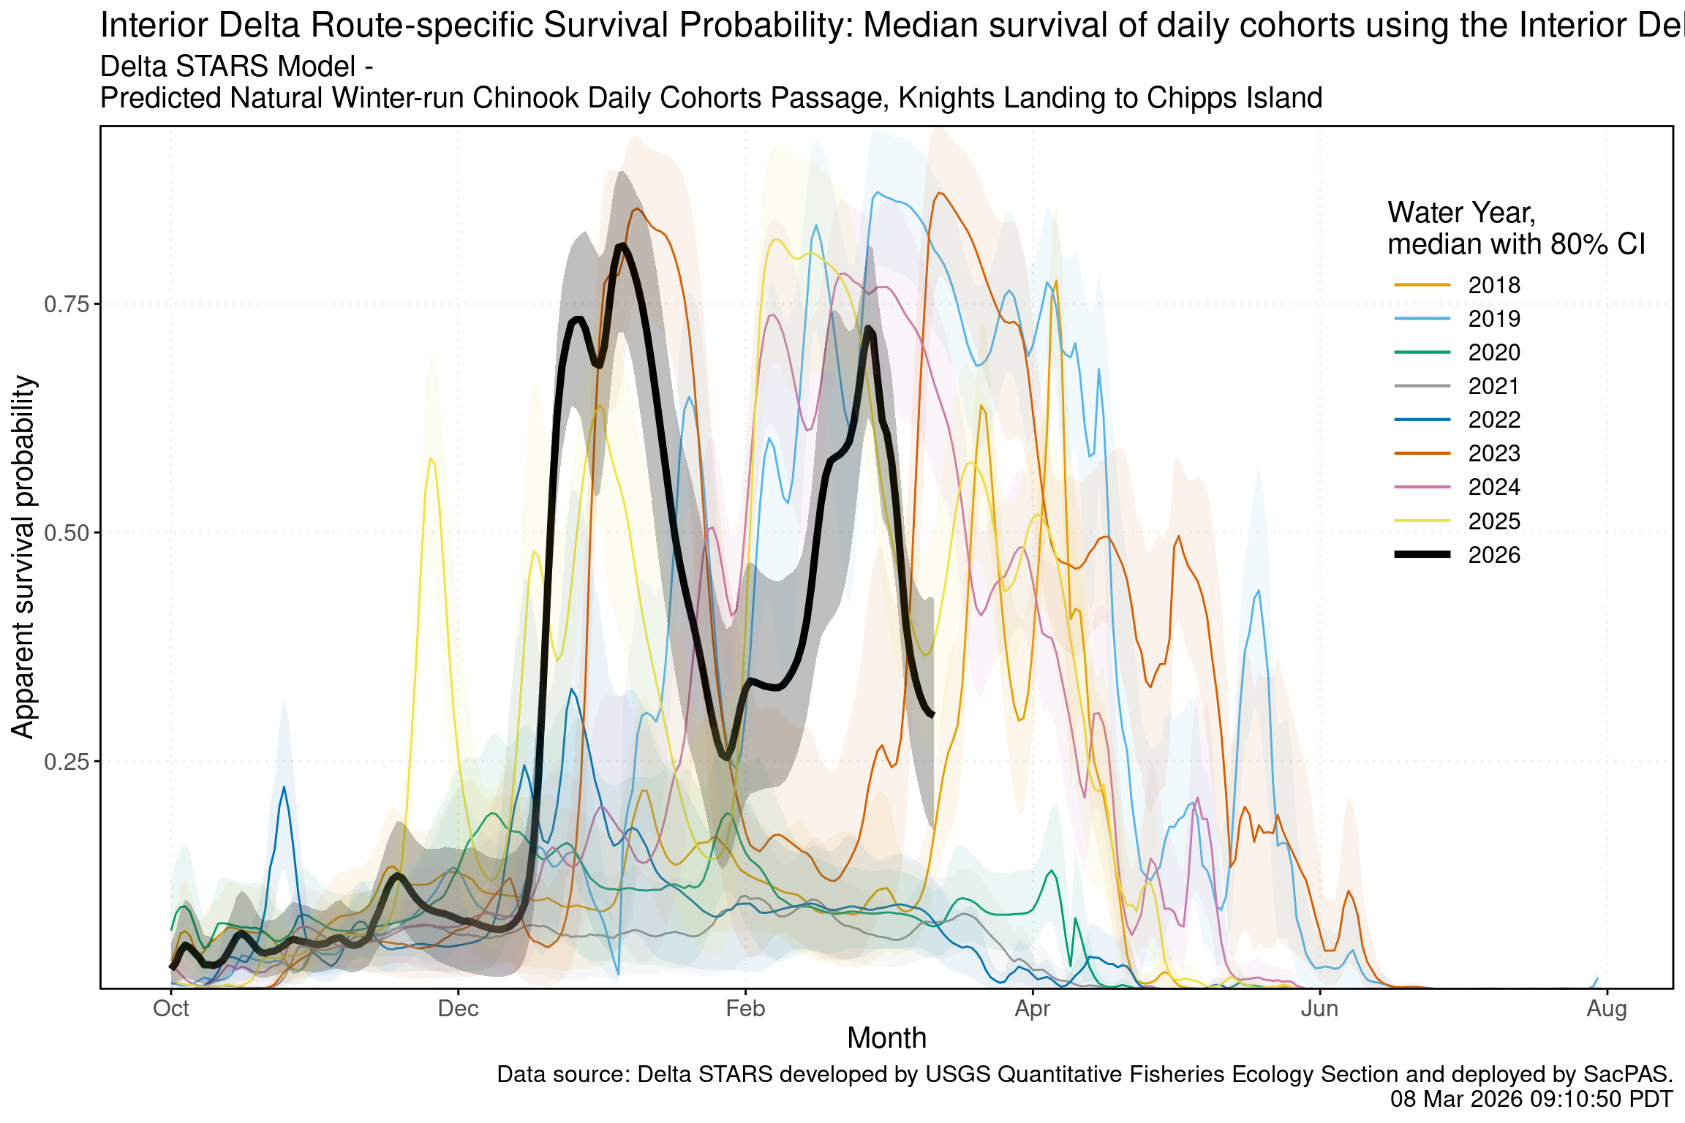
Figure 5: Estimated survival from Knights Landing to Chipps Island of simulated winter-run cohorts that route through the interior Delta. Black line indicates the current water-year, and other colored lines correspond to past water years.
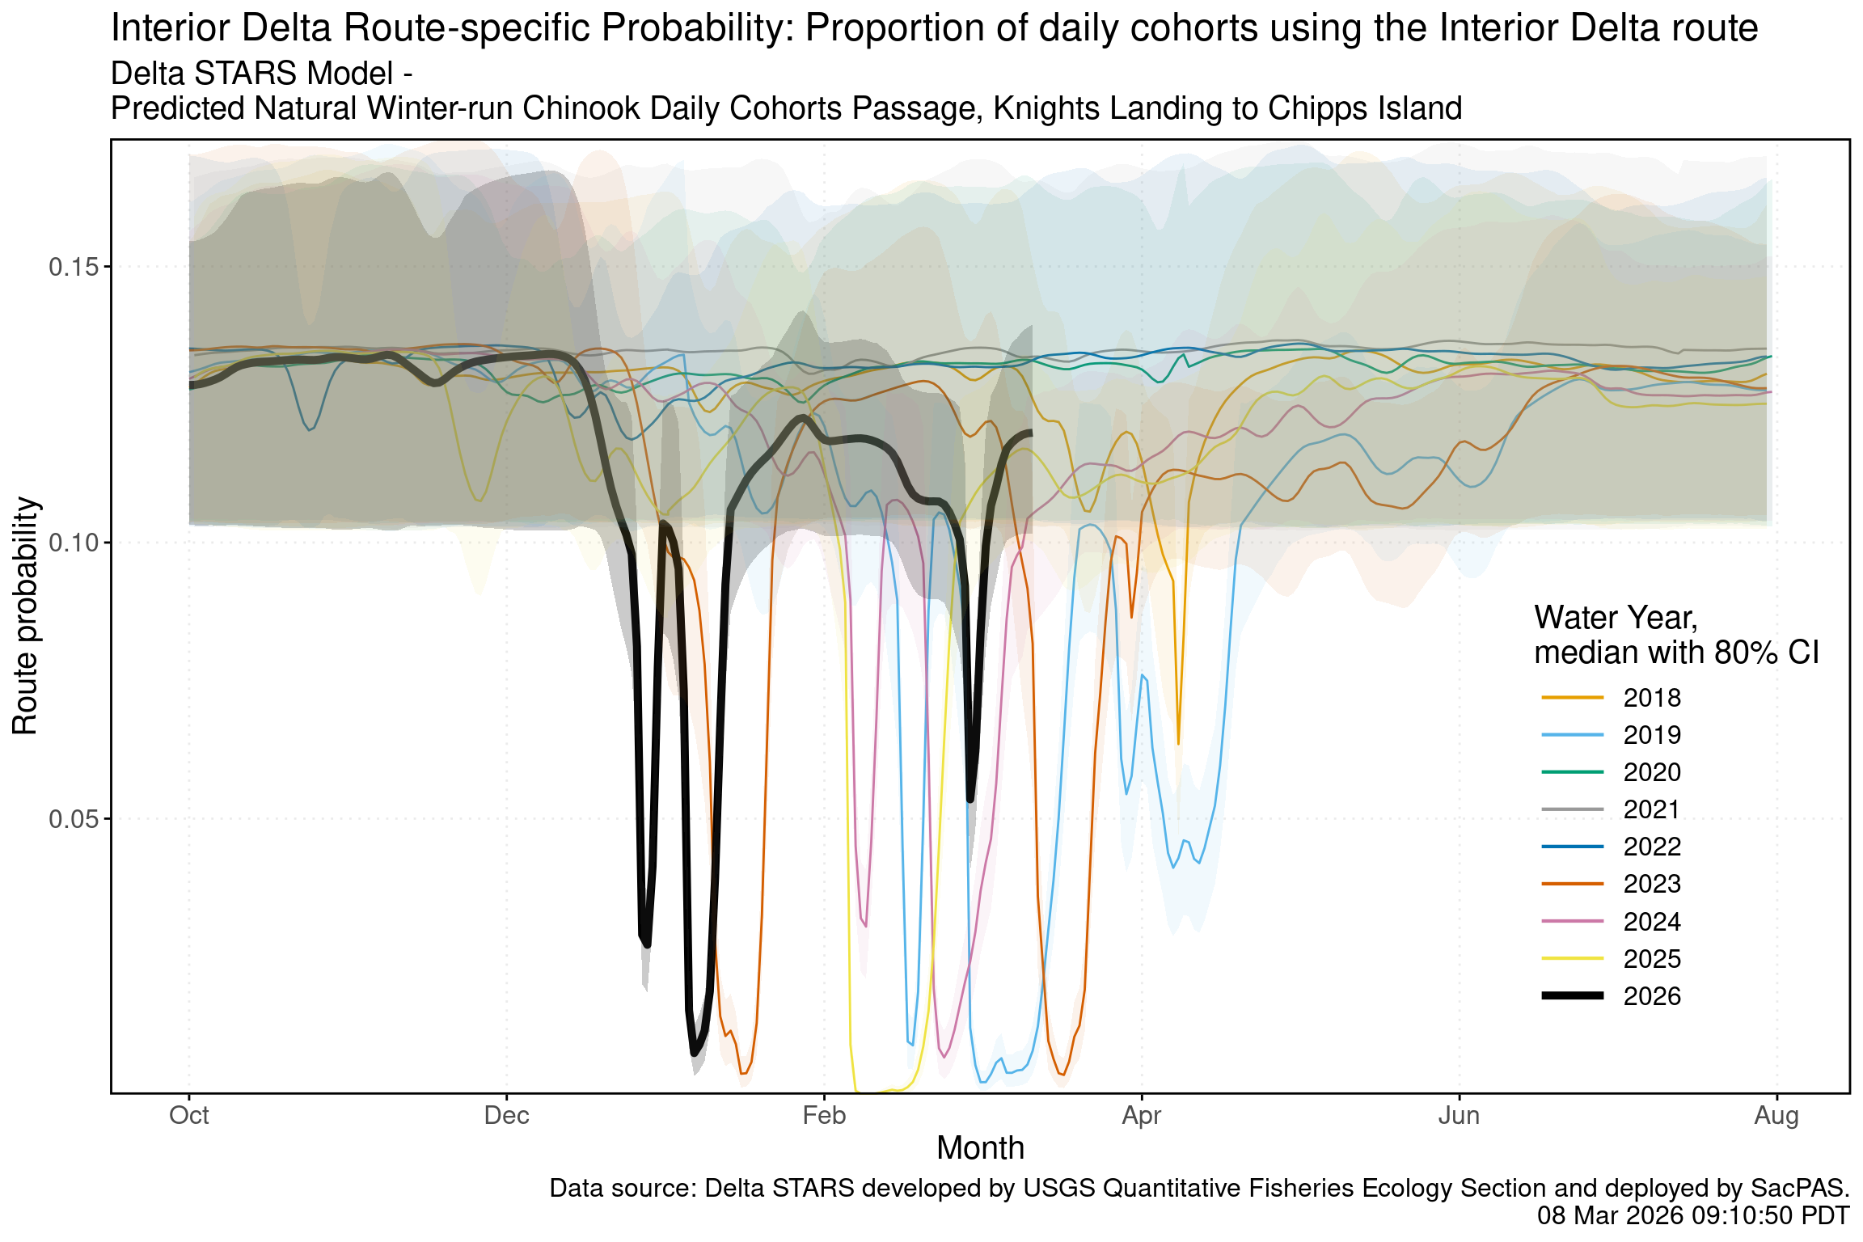
Figure 6: Estimated probability of winter-run routing into the interior Delta. Black line indicates the current water-year, and other colored lines correspond to past water years.

2.2 Hatchery Winter-run Chinook

2.2.1 Hatchery Releases
Livingston Stone National Fish Hatchery released a total of 466,344 winter-run Chinook salmon (February 18). All fish were 100% CWT-marked production fish released at the Sacramento River at John F. Reginato River Access. Release details are shown in the table below and available on SacPAS.
Table 3: Livingston Stone NFH winter-run Chinook salmon releases in Water Year 2026. Data sourced from SacPAS.
Release Date | Hatchery | Release Site | Release Type | Fish Released | % CWT Marked | CWT Tagcodes
February 18, 2026 | Livingston Stone NFH | Sacramento River at John F. Reginato River Access | Production | 466,344 | 100% | 053800 056770 056788 056789

2.2.2 Juvenile Production Estimate
The Juvenile Production Estimate for hatchery winter-run is 130,096 for Livingston Stone releases. The annual loss threshold is 1% of the JPE (1,301 fish), which is the same as the single-year ITL (BiOp Table 184).

2.2.3 Annual Loss
As of March 09, cumulative loss of Livingston Stone hatchery fish is 0 or 0.00% of the annual loss threshold (which equals the single-year ITL). Cumulative loss in the past 7 days has been 0.

2.3 Natural-origin Central Valley Steelhead

2.3.1 Current Status
Delta Entry Timing - Historically, as of Mar 08, 51% of CCV steelhead have entered the Delta based on Knights Landing RST catch, 40% have exited the Delta based on Chipps Island Trawl Catch, and 31% have been salvaged.
Table 4: Average percent of annual emigrating population for unclipped CCV steelhead captured at monitoring locations and salvaged at Delta facilities for the past 10 years.
Species | Chipps Island Trawl | Knights Landing RST | Red Bluff Diversion Dam | Sac Trawl (Sherwood) | Salvage | Tisdale RST
Steelhead, Unclipped | 40% | 45% | 2% | 51% | 31% | 45%
Delta Monitoring - Total catch of unclipped steelhead at RSTs at Delta Entry (Tisdale, Knights Landing, Lower Sacramento River) between Feb 22 and Mar 05 is 3 individuals. Total catch at Sacramento Trawl and Beach Seines in the delta between Feb 23 and Mar 05 is 0 individuals. Total catch at Delta Exit at Chipps Island between Feb 23 and Mar 05 is 0 individuals.

2.3.2 Annual Loss
As of March 08, cumulative loss of unclipped steelhead is 182 or 3.43% of the single-year incidental take limit (ITL). There is no annual loss threshold for natural steelhead. The single-year ITL is 5,294 juveniles or 2,319 juveniles as a 3-year rolling average (BiOp Table 184). Cumulative loss in the past 7 days has been 155.
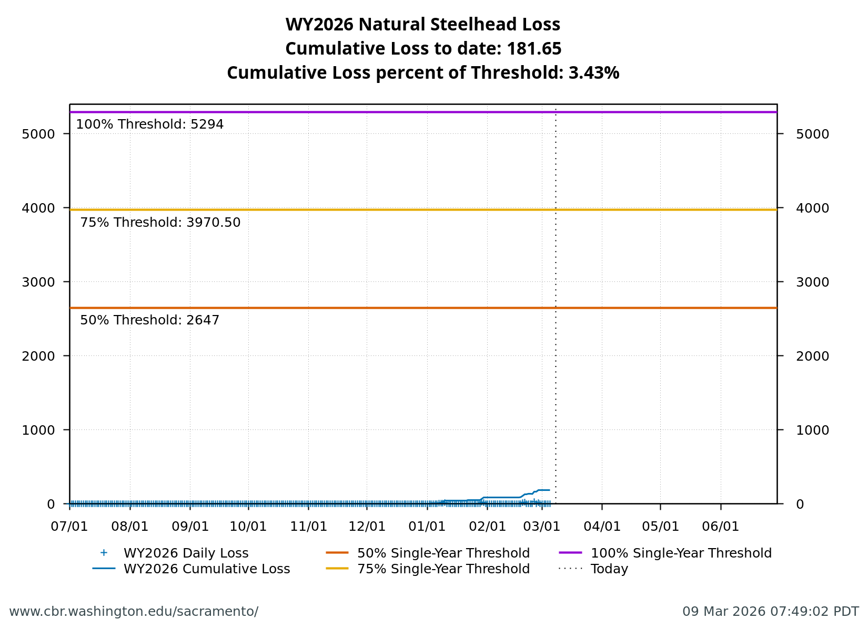
Figure 7: Cumulative loss of natural-origin steelhead for WY 2026. The 5,294 line represents the single-year incidental take limit (ITL), not a loss threshold.

2.4 Hatchery-origin Central Valley Steelhead

2.4.1 Surrogate Releases
There have been a total of 7 releases totaling 1,451,464 steelhead in Water Year 2026. JPE for the hatchery releases as of today is 610,752 based on estimated survivals using forecasted water year types (see details in table below). The annual loss threshold, equal to 1% of the JPE, is currently 6,108, but is subject to change with additional steelhead releases.
Table 5: Summary of steelhead hatchery releases in Water Year 2026. JPE calculated using hatchery-specific survival estimates to Delta entry from release location.
Hatchery | Date of Release | Number Released | Estimated Survival | Juvenile Production Estimate
NIM | 2025-11-10 | 233,109 | 72% | 167,838
Coleman | 2025-12-15 | 555,720 | 38% | 211,174
Coleman | 2025-12-17 | 90,019 | 38% | 34,207
FRH | 2026-01-06 | 376,640 | 36% | 135,590
FRH | 2026-01-09 | 117,715 | 36% | 42,377
MOK | 2026-02-17 | 39,130 | 25% | 9,783
MOK | 2026-02-18 | 39,131 | 25% | 9,783
Table 6: Hatchery-specific survival estimates used for JPE calculations.
Hatchery | Survival Estimate | Source
Coleman NFH | 0.205 – 0.433 | Sandstrom et al. 2020
Feather River Hatchery | 0.09 – 0.45 | Kurth 2013
Nimbus Hatchery | 0.62 – 0.83 | Brodsky et al. 2020
Mokelumne River Hatchery | 0.25 – 0.33 | Del Real et al. 2012
Total loss of hatchery-origin steelhead is 986 or 16.14% of the annual loss threshold. Note that hatchery origin of salvaged fish cannot be determined at this time and salvage is based on the assumption of similar routing and survival probabilities of individual hatchery releases.
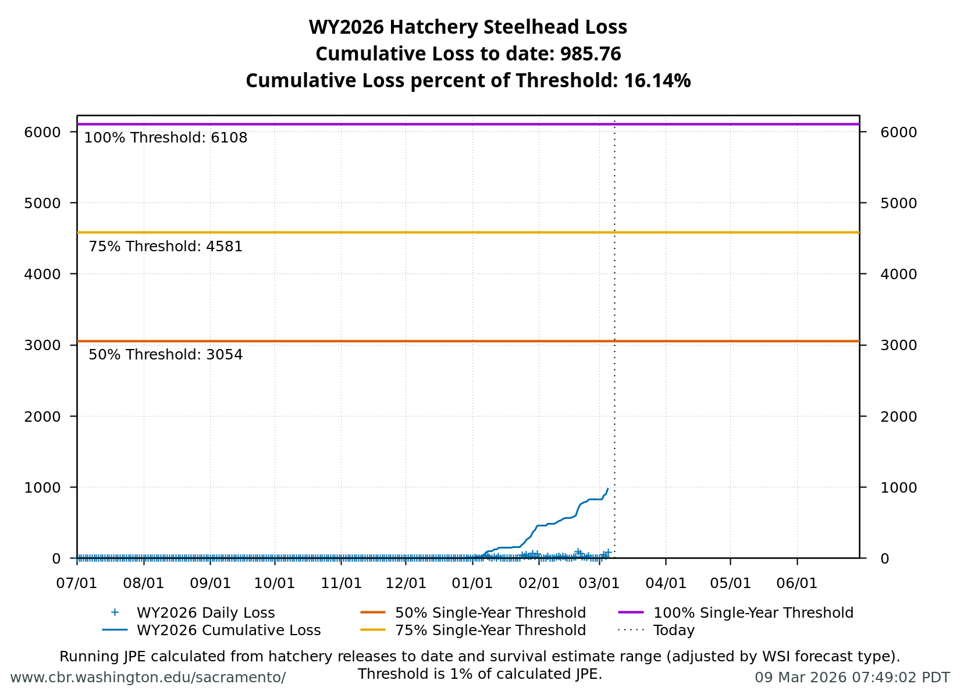
Figure 8: Cumulative loss of hatchery steelhead for WY 2026.

2.5 Spring-run Chinook

2.5.1 Current Status
Delta Entry Timing - Historically, as of Mar 08, 6% of LAD spring-run have entered the Delta based on Knights Landing RST catch, 0% have exited the Delta based on Chipps Island Trawl Catch, and 2% have been salvaged.
Table 7: Average percent of annual emigrating population for LAD spring-run Chinook salmon captured at monitoring locations and salvaged at Delta facilities for the past 10 years.
Species | Red Bluff Diversion Dam | Tisdale RST | Knights Landing RST | Sac Trawl (Sherwood) | Chipps Island Trawl | Salvage
Chinook, LAD Spring-run, Unclipped | 17% | 19% | 32% | 6% | 0% | 2%
Red Bluff Diversion Dam Passage Estimate - As of Mar 04 estimated passage to date of LAD spring-run at Red Bluff Diversion is approximately 0.03 million fish. Note that outmigration timing overlaps with winter-run and fall-run outmigration, and true spring-run abundance likely differs from these estimates.
Delta Monitoring - Total catch of LAD spring-run at RSTs at Delta Entry (Tisdale, Knights Landing, Lower Sacramento River) between Feb 22 and Mar 05 is 56 individuals. Total catch at Sacramento Trawl and Beach Seines in the delta between Feb 23 and Mar 05 is 64 individuals. Total catch at Delta Exit at Chipps Island between Feb 23 and Mar 05 is 8 individuals.

2.5.2 Spring-run Surrogate Releases
A total of 805,323 spring-run surrogate fish have been released in Water Year 2026, with an estimated Juvenile Production Estimate (JPE) of 219,852 fish entering the Delta. This includes 805,323 Coleman Late-Fall Run Chinook (JPE: 219,852) released from Coleman National Fish Hatchery across 12 coded-wire tag groups. See details in table below.
Table 8: Spring-run Chinook salmon surrogate releases (all Coleman Late-Fall releases, both production and experimental).
Hatchery | Release Date | Type | # of CWT Fish Released | JPE | ITL (0.5%) | Confirmed Loss | CWT Codes
Coleman NFH | 2025-11-13 | Production | 143,346 | 39,134 |  | 9 | 056808, 056809
Coleman NFH | 2025-11-17 | Experimental | 75,119 | 20,507 | 376 | 0 | 056810
Coleman NFH | 2025-12-17 | Production | 468,876 | 128,002 |  | 757 | 053700, 056806, 056811, 056812, 056814, 056815, 056817
Coleman NFH | 2025-12-22 | Experimental | 60,873 | 16,618 | 304 | 257 | 056813
Coleman NFH | 2026-01-08 | Experimental | 57,109 | 15,591 | 286 | 35 | 056816

2.5.3 Annual Loss
The annual loss threshold is 1% of the JPE entering the Delta, which equals 2,199 fish. As of March 08, cumulative loss is 1,058 fish or 48.12% of the annual loss threshold. The single-year incidental take limit (ITL) is 0.5% of the estimated number of each surrogate release group (BiOp Table 184). ITL status by experimental release group: Release Group 1 (2025-11-17): 0 loss of 376 ITL (0%); Release Group 2 (2025-12-22): 257 loss of 304 ITL (84.64%); Release Group 3 (2026-01-08): 35 loss of 286 ITL (12.26%)

2.6 Loss Prediction and Trajectories
The following figures display the current loss predictor model outputs for winter-run Chinook salmon and steelhead.
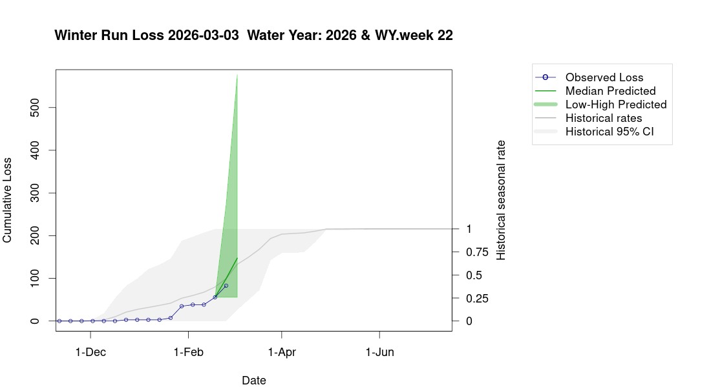
Figure 9: Estimates of winter-run Chinook loss generated by Loss and Salvage Predictor tool.
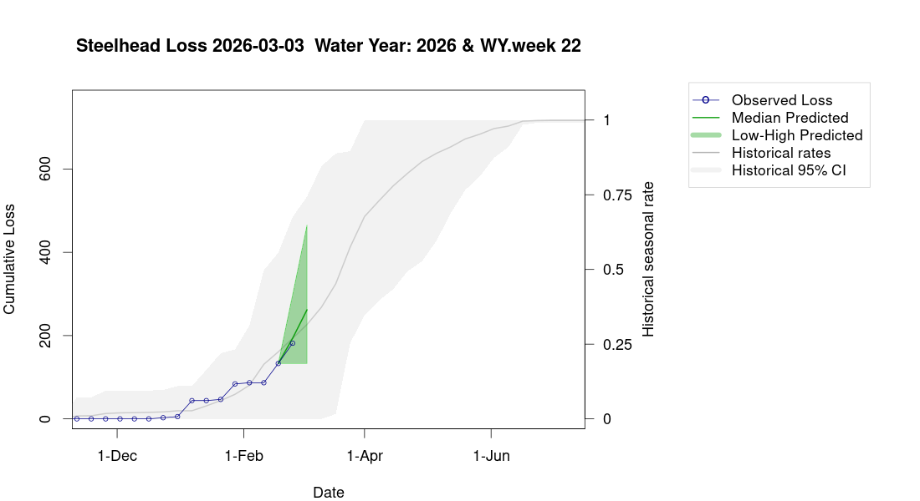
Figure 10: Estimates of steelhead loss generated by Loss and Salvage Predictor tool.

2.7 Evaluation
- What is the probability of exceeding natural or hatchery winter-run Chinook salmon loss thresholds in the upcoming week?
- LOW RISK: Natural winter-run cumulative loss is currently 0.03% of the threshold. LOW RISK: Hatchery winter-run cumulative loss is currently 0.00% of the threshold.
- What is the probability of exceeding spring-run Chinook salmon surrogate yearling loss thresholds in the upcoming week?
- LOW RISK: Spring-run surrogates cumulative loss is currently 48.12% of the threshold.
- What is the probability of exceeding natural or hatchery steelhead loss thresholds in the upcoming week?
- LOW RISK: Natural steelhead cumulative loss is currently 3.43% of the threshold. LOW RISK: Hatchery steelhead cumulative loss is currently 16.14% of the threshold.

References
Brodsky, A., Zeug, S. C., Nelson, J., Hannon, J., Anders, P. J., & Cavallo, B. J. (2020). Does broodstock source affect post-release survival of steelhead? Implications of replacing a non-native hatchery stock for recovery. Environmental Biology of Fishes, 103(5), 437–453.
Del Real, S. C., Workman, M., & Merz, J. (2012). Migration characteristics of hatchery and natural-origin oncorhynchus mykiss from the lower mokelumne river, california. Environmental Biology of Fishes, 94(2), 363–375.
Kurth, R. (2013). Downstream migration success of feather river fish hatchery steelhead smolts under different release strategies.
Sandstrom, P. T., Ammann, A. J., Michel, C., et al. (2020). Low river survival of juvenile steelhead in the sacramento river watershed. Environmental Biology of Fishes, 103(5), 531–541.

