Weekly Assessment for Delta Operations on ESA and CESA-listed Osmerids including Current Delta Hydrologic Conditions
  - Last updated: Monday, March 09, 2026 at 8 AM
Table of contents

Executive Summary
- Entrainment management is currently active.
- Delta smelt were most recently detected at Suisun Marsh.
- No Delta smelt or longfin smelt salvage has been observed this water year.
- Turbidity in the central/south Delta is low to moderate.

1 Current Delta Hydrologic Conditions

1.1 Operational and Regulatory Conditions
The current controlling factor is OMRI restrictions to no more negative than -5,000 cfs. See most recent weekly outlook for more information.

1.2 Current Conditions
Most recent inflow at Freeport in the Sacramento River and Vernalis in the San Joaquin River is 37,997 and 5,351 cfs respectively. Most recent Jersey Point Flow (JPF) is 6,075 cfs. Most recent 1-day, 5-day, and 14-day OMRI measurements were -4,951, -4,950, and -5,061 cfs, respectively, and most recent export data were 3,551 cfs for Jones Pumping Plant and 1,734 cfs for Henry O. Banks Pumping Plant.
Figure 1: Operations and Action Summary, WY 2026. The numbers and lines in the OMRI plot indicate different triggers and thresholds (see Table 1), with shading representing specific action periods. Dashed and dotted vertical lines represent triggered actions and thresholds, respectively. OMRI data (colored lines) calculated by SacPAS, Freeport (FPT) and Vernalis (VNS) flow data from CDEC, Jersey Point Flow (JPF) from DWR, and CVP (TRP) and SWP (HRO) exports data from CDEC.
Table 1: Summary of Actions and Triggers, WY 2026
Label | Action | Date Triggered | Date Implemented | Number Days Implemented | Regulation
1 | DCC Gate Closure | 10/28/2025 | 2025-10-30 | Ongoing | DCC gates
2 | First Flush | 12/24/2025 | 2025-12-25 | 14 days | Entrainment Management
3 | Offramp temperature threshold | 2/12/2026 |  | 3 consecutive days | Delta Smelt Adult Entrainment, no action taken WY26

1.3 Zone of Influence
Zone of Influence (ZOI) analysis is discussed in detail in the December 22 assessment. Current conditions were queried from most recent Freeport flow data on the Sacramento River and Vernalis flow data on the San Joaquin river from SacPAS. Forecasted flows were queried from short range deterministic flows provided by the California Nevada River Forecast Center.
Current conditions at Freeport and Vernalis indicate that delta hydrology falls within the ‘hihi’ category. Forecasted conditions averaged across the next 7 days falls within the ‘hihi’ category.
The altered channel length for the current “hihi” hydrology is 99, 100, 119 and 114 kilometers (km) across OMR bins of -2000, -3500, -5000 and <-5500 respectively. The altered channel length for forecasted “hihi” hydrology is 99, 100, 119 and 114 kilometers (km) across OMR bins of -2000, -3500, -5000 and <-5500 respectively.
Change in altered channel length between OMR levels is 15 km for current conditions and 15 km for forecasted conditions indicating that ZOI impacts across OMR scenarios would not change between current and forecasted conditions. Across the nine hydrology bins, changes in altered channel length across OMR scenarios are low (<25th percentile) for both current and forecasted hydrology.
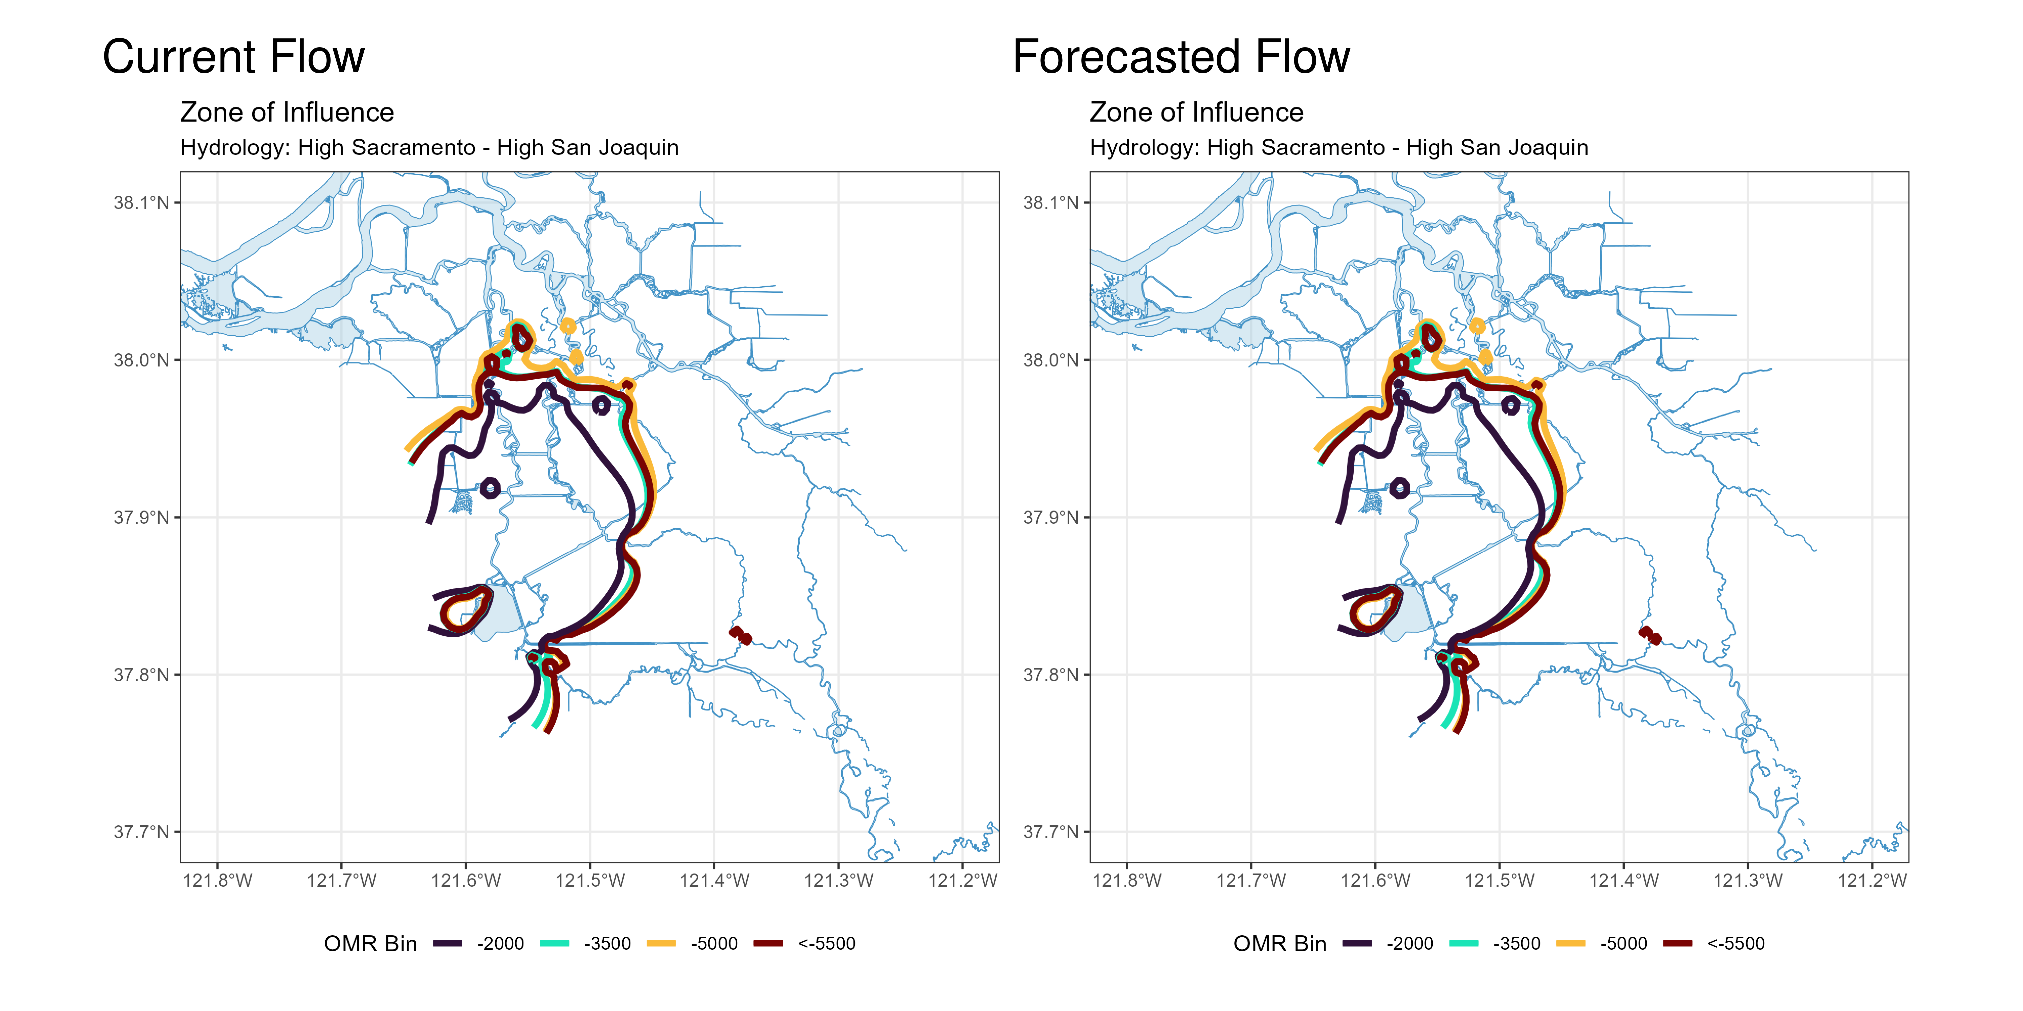
Figure 2: Modeled Zone of Influence at different OMRI scenarios based on current inflow hydrology (left) and forecasted inflow hydrology (right) from the Sacramento River and San Joaquin River

2 Weekly Assessment for Delta Operations on ESA and CESA-listed Osmerids

2.1 Operational and Regulatory Conditions
- See current Weekly Fish and Water Operations Outlook document.
- Additional information also available on the SacPAS SMT page.

2.2 Delta smelt

2.2.1 Biological
- Delta smelt life stages: Juvenile, Adult
- Abundance estimate: 9901 (95% CL: 1,407 to 35,401) as of the week of February 23–27, 2026
- Releases: A total of 163,349 cultured Delta smelt have been released for WY 2026. The most recent release of 24,606 fish occurred in Sacramento River at Rio Vista on Dec 16, 2025.
- Delta smelt count: 40 adult Delta smelt and 30 juvenile Delta smelt have been detected this water year. See Table 2 for recent detections, Figure 3 for spatial distribution, and Figure 4 for temporal distribution.
- Delta smelt salvage: 0 Delta smelt have been salvaged, and the cumulative seasonal salvage is 0.
Notes
- Since there are few recent detections of Delta smelt, estimation of distribution within the Delta is limited.
- As mentioned in EDSM reporting, fork length ranges reported for Delta smelt and longfin smelt life stages are defined by permit reporting purposes and are not intended to delineate cohorts or distinguish from hatchery or wild origin. See Table 2 caption for fork-length ranges for age groups of Delta smelt.
- See SacPAS SMT Page for additional details on releases and detection in surveys and salvage.
- Historical salvage trends can be found at: SacPAS Salvage Timing
Table 2: Delta smelt detections in the last 2 weeks. Fork Length > 58mm = Adult, Fork Length 20-58mm = Juvenile, Fork Length < 20mm = Larva.
Survey | Date | Region | Stratum | Life Stage | Catch
EDSM | 2026-02-25 | West | Suisun Marsh | Adult | 3
EDSM | 2026-02-25 | West | Suisun Marsh | Juvenile | 1
EDSM | 2026-03-02 | West | Suisun Marsh | Adult | 1

Figure 3: Delta smelt distribution for WY 2026
Table 3: Delta smelt water year totals by life stage
Survey | Region | Life Stage | Total
DJFMP | N/A | Adult | 1
DJFMP | North | Juvenile | 1
EDSM | North | Adult | 2
EDSM | West | Adult | 37
EDSM | West | Juvenile | 29

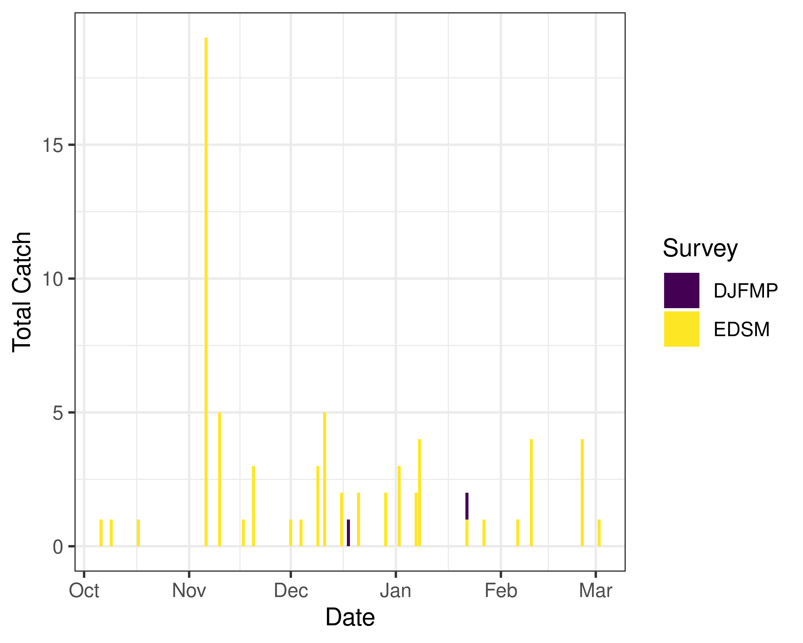
Figure 4: Time series of Delta smelt catch, WY 2026

2.2.2 Environmental

2.2.2.1 First Flush
- Implemented 12/25/25-01/7/26

2.2.3 Real-time Assessment Thresholds

2.2.3.1 Adult Delta smelt
- Adult Delta smelt action offramped on 02/12/2026
- No adult Delta smelt action was taken in WY26
- See Bay-Delta Live for recent Delta-wide turbidity conditions.

2.2.3.2 Larval/juvenile Delta smelt
Threshold: After the onset of spawning, if JPF < 0 cfs AND turbidity is $≥$ 12 FNU in the south Delta AND PTM modeling indicates the action would avoid $≥$ 5% entrainment of Delta smelt population after 30 days
- 12-station South Delta Turbidity: The most recent average turbidity was 12.5 FNU as of Feb 23, 2025

2.2.4 Evaluation
Delta smelt:
- After the start of entrainment management, is JPF < 0, is daily average turbidity ≥ 12 FNU in the OMR corridor (stations OBI, HOL, and OSJ)? Has the average water temperature at Jersey Point or Rio Vista not exceeded 53.6$​^{∘}$F (12$​^{∘}$C) for 3 consecutive days and/or has this action already been taken during WY 2026?
- The adult Delta smelt entrainment action is not active and no action was taken in WY26. Temperature at Jersey Point exceeded the threshold on February 12th, 2025. Jersey Point 3-day average temperature was 12.05°C on February 10th, 12.09°C on February 11th, and 12.13°C on February 12th.
- What is the evidence for the onset of Delta smelt spawning?
- Upstream migration for Delta smelt occurs between December and March and in response to “first flush” conditions (Sommer et al., 2011; Grimaldo et al. 2009; 2021). Historically, detections of ripe Delta smelt began in January and peaked in February and March and the majority of Delta Smelt spawning occurs at 11-15˚C (but can occur from 8-18˚C) (Damon et al. 2016). Based on historical monitoring data from the past few years, first detection of larvae in the Central and South Delta has typically occurred by mid to late March. The large majority of Delta smelt recaptures continue to be from Suisun Marsh, close to where supplemental fish were released in the fall.
- After the onset of spawning, have the following conditions occurred: JPF < 0 cfs, average turbidity is $≥$ 12 FNU in the south Delta, and PTM modeling indicates the action would avoid $≥$ 5% entrainment of the Delta smelt population at facilities after 30 days?
- Although spawning may be occurring, JPF is above 0 cfs. SLS 5 was on the water last week, and the most recent 12 station average turbidity in the south delta was 12.5 FNU on 2/23/26. Due to JPF > 0 this week, the conditions required to trigger larval and juvenile Delta smelt entrainment management will not be met. No Delta smelt larvae have been captured in SLS surveys in WY26 to date.
If a Storm Flex operation were implemented during the forecast week ending March 9, 2026, particle fate modeling at Chipps Island and Cache Slough would be most relevant, as these locations are closest to recent adult distribution.
For particles injected at Chipps Island, Particle Tracking Model (PTM) results indicate 0% entrainment at both CVP and SWP across all evaluated OMRI levels (−6,500, −5,000, −3,500, and −2,000 cfs) for both the week ending March 9, 2026 and the week ending March 16, 2026.
For particles injected at Cache Slough, low levels of entrainment are modeled at more negative OMRI levels. For the week ending March 9, 2026, entrainment is 0.0% at CVP across all evaluated OMRI levels, and SWP entrainment is 0.1% at OMRI −6,500 cfs and 0.1% at OMRI −5,000 cfs, with 0.0% at OMRI −3,500 cfs and −2,000 cfs. For the forecast week ending March 16, 2026, entrainment is again 0.0% at CVP across all evaluated OMRI levels, and SWP entrainment is 0.3% at OMRI −6,500 cfs and 0.1% at OMRI −5,000 cfs and −3,500 cfs, with 0.0% at OMRI −2,000 cfs (see Appendix A for details).
These results indicate that if Delta smelt larvae were present, the risk of entrainment under potential Stormflex operations would be low.

2.3 Longfin smelt

2.3.1 Biological
- Longfin smelt life stages: Juvenile, Larva, Adult
- Longfin smelt count: 427 adult, 1013 juvenile, and 3195 larval longfin smelt have been detected this water year. See Table 4 for recent detections, Figure 5 for spatial distribution, and Figure 6 for temporal distribution.
- Longfin smelt salvage: 0 longfin smelt have been salvaged, and the cumulative seasonal salvage is 0.
Table 4: Longfin smelt detections in the last 2 weeks. Fork Length > 84mm = Adult, Fork Length 20-84mm = Juvenile, Fork Length < 20mm = Larva.
Survey | Date | Region | Stratum | Life Stage | Catch
DJFMP | 2026-02-25 | N/A | Chipps Island | Adult | 3
DJFMP | 2026-02-25 | N/A | Chipps Island | Juvenile | 1
DJFMP | 2026-02-26 | N/A | Chipps Island | Adult | 1
DJFMP | 2026-02-26 | N/A | Chipps Island | Juvenile | 1
DJFMP | 2026-02-27 | N/A | Chipps Island | Adult | 1
DJFMP | 2026-03-02 | N/A | Chipps Island | Adult | 1
DJFMP | 2026-03-03 | N/A | Chipps Island | Adult | 2
DJFMP | 2026-03-03 | N/A | Chipps Island | Juvenile | 1
DJFMP | 2026-03-04 | N/A | Chipps Island | Adult | 3
DJFMP | 2026-03-05 | N/A | Chipps Island | Adult | 1
DJFMP | 2026-03-05 | N/A | Chipps Island | Juvenile | 1
EDSM | 2026-02-24 | West | Suisun Bay | Juvenile | 1
EDSM | 2026-02-25 | West | Suisun Marsh | Juvenile | 3
EDSM | 2026-02-26 | Far West | Western Delta | Juvenile | 2
EDSM | 2026-03-03 | Far West | Suisun Bay | Juvenile | 1
EDSM | 2026-03-03 | West | Suisun Bay | Juvenile | 1
EDSM | 2026-03-05 | Far West | Western Delta | Adult | 2
EDSM | 2026-03-05 | Far West | Western Delta | Juvenile | 3
sls | 2026-02-24 | North | Cache Slough/Liberty Island | Larva | 3
sls | 2026-02-24 | North | Lower Sacramento | Larva | 3
sls | 2026-02-24 | West | Lower Sacramento | Larva | 3
sls | 2026-02-24 | NA | NA | Larva | 26
sls | 2026-02-25 | West | Suisun Bay | Larva | 91

Figure 5: Longfin Smelt Distribution for WY 2026
Table 5: Longfin smelt water year totals by life stage
Survey | Region | Life Stage | Total
DJFMP | Bay | Juvenile | 1
DJFMP | N/A | Adult | 255
DJFMP | N/A | Juvenile | 22
DJFMP | NA | Adult | 1
EDSM | Far West | Adult | 23
EDSM | Far West | Juvenile | 91
EDSM | North | Juvenile | 1
EDSM | West | Adult | 80
EDSM | West | Juvenile | 200
FMWT | Bay | Adult | 1
FMWT | Bay | Juvenile | 14
FMWT | Far West | Adult | 2
FMWT | Far West | Juvenile | 14
FMWT | West | Adult | 4
FMWT | West | Juvenile | 18
FMWT | NA | Adult | 2
FMWT | NA | Juvenile | 28
baystudy | Bay | Adult | 39
baystudy | Bay | Juvenile | 551
baystudy | Far West | Adult | 13
baystudy | Far West | Juvenile | 56
baystudy | North | Adult | 3
baystudy | West | Adult | 4
baystudy | West | Juvenile | 14
sls | Bay | Larva | 125
sls | Far West | Larva | 1906
sls | North | Larva | 83
sls | South | Larva | 49
sls | West | Larva | 959
sls | NA | Juvenile | 3
sls | NA | Larva | 73

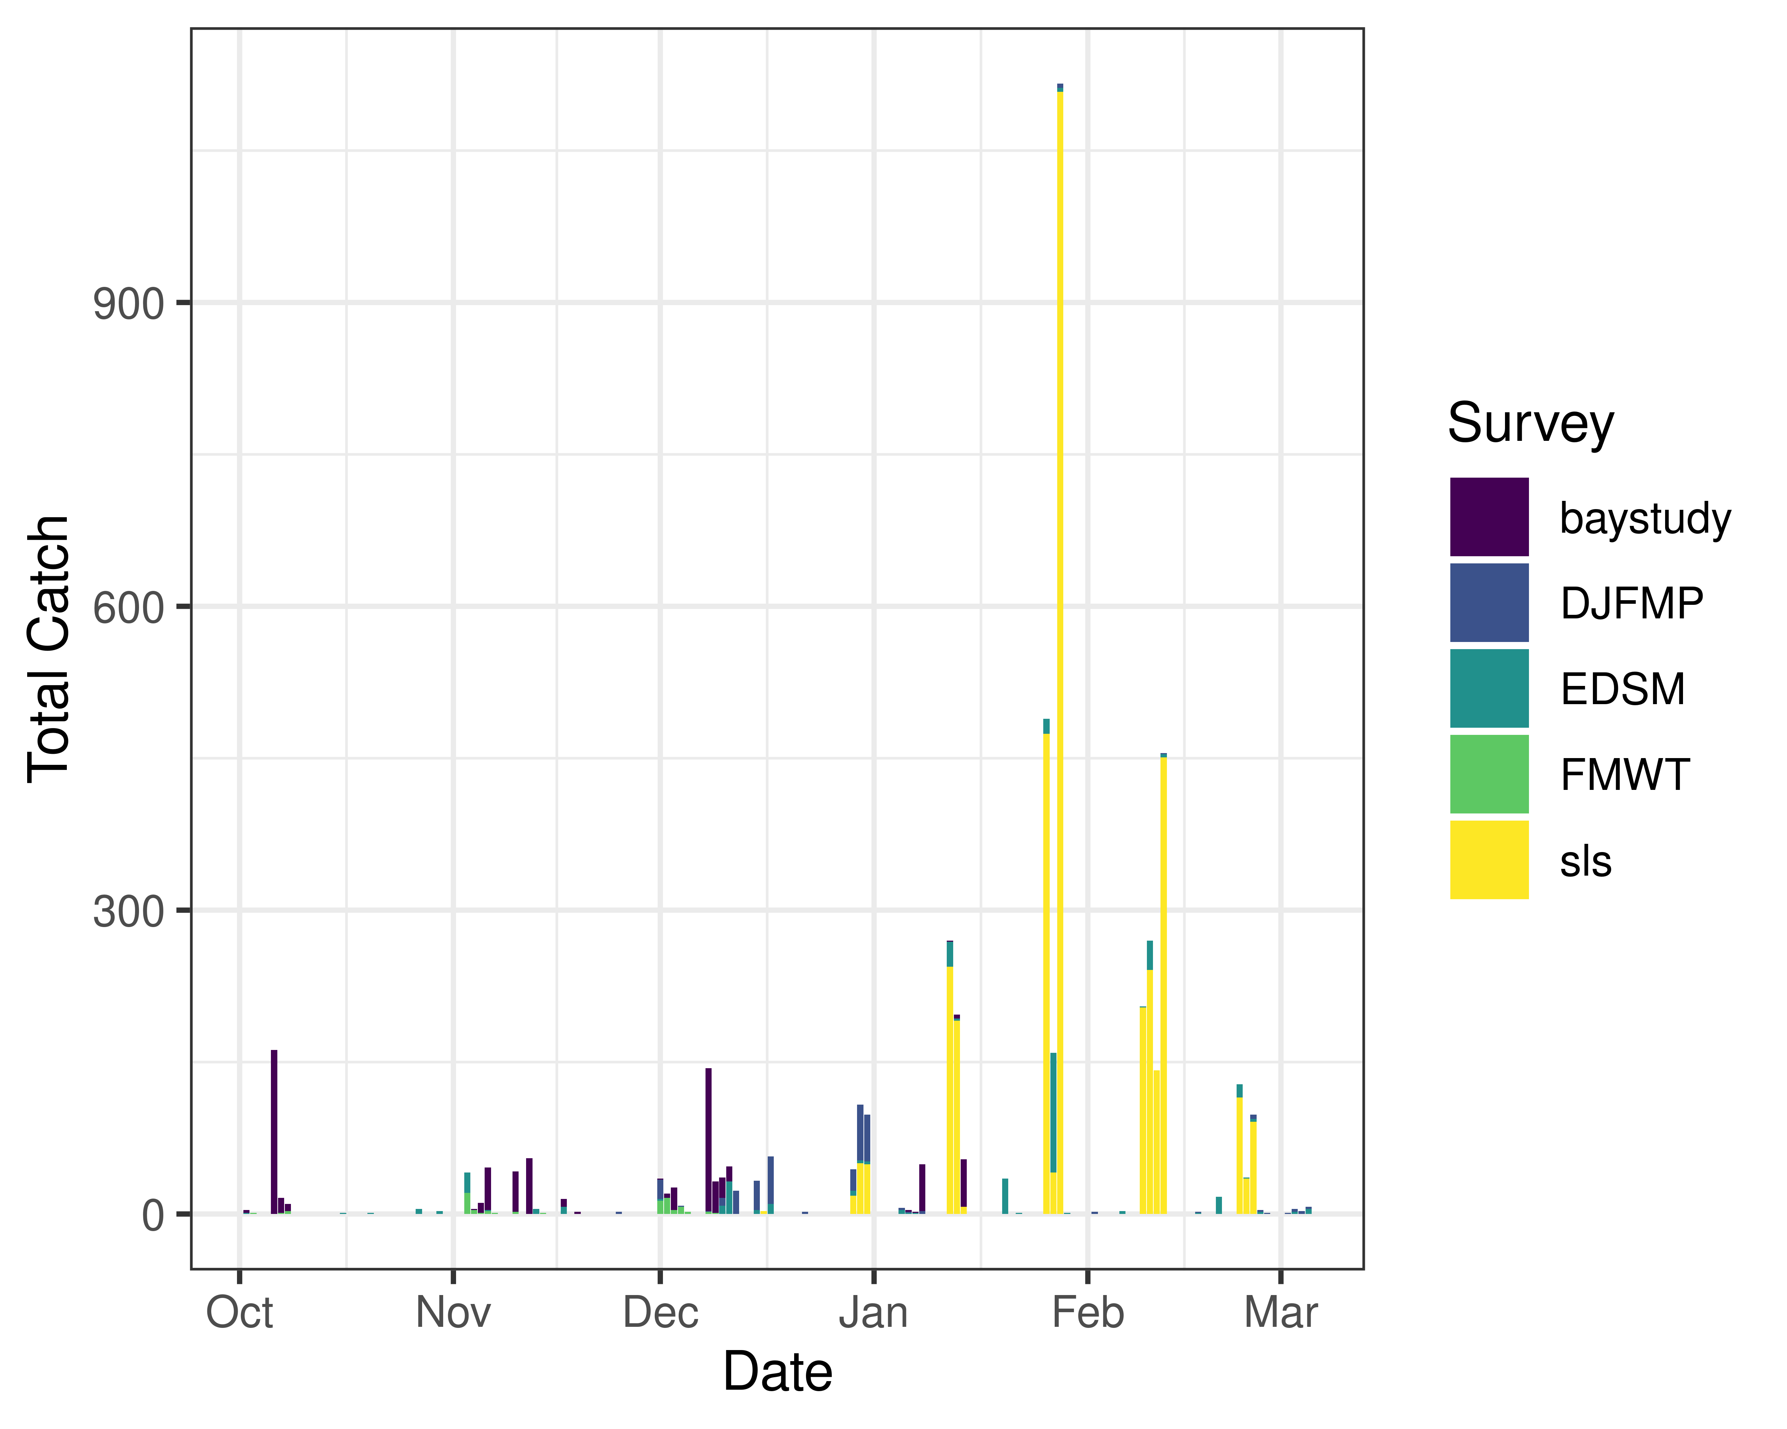
Figure 6: Time series of longfin smelt catch, WY 2026

2.3.2 Real-time Assessment Thresholds

2.3.2.1 Start of Entrainment Management (Adult Longfin Smelt)
- This action was not taken in WY26

2.3.2.2 Adult longfin smelt
- Threshold: JPF < 0 cfs, annual loss is on a trajectory to exceed 5% of the adult population abundance, and reduced exports will reduce entrainment in the south Delta
  - Daily average JPF: 6,075 cfs as of Mar 08, 2026
  - Adult abundance (Age 1+ LFS index): 2479.2 fish
    - 5% of abundance + 1: 125.0
  - Water year total adult longfin smelt salvage = 0

2.3.2.3 Larval/juvenile longfin smelt
- Threshold: JPF < 0 cfs AND population model demonstrates need to reduce entrainment to avoid population decline
  - Daily average JPF: 6,075 cfs as of Mar 08, 2026

2.3.3 Evaluation
Longfin smelt:
- If JPF < 0, what is the trajectory of annual loss of adult longfin smelt and is it likely to exceed 5% of the adult population estimate? Is South Delta entrainment expected to decrease due to a reduction in export pumping?
- JPF is > 0 cfs and no adult longfin smelt have been detected in salvage, indicating annual loss has not begun to approach the 5% regulatory threshold.
- For larval and juvenile longfin smelt, if JPF < 0 cfs, do particle tracking models show a moderate to high difference in particle fates across different OMRI scenarios? Does Zone of Influence modeling show moderate to high changes in hydrodynamic footprint across different OMRI scenarios? Are these effects anticipated to cause a population decline?
- JPF is currently not less than 0 cfs and is not predicted to drop below 0 cfs this week. Zone of Influence modeling indicates low differences in the hydrodynamic footprint across OMRI scenarios, with no change between current and forecasted conditions. If a Stormflex action were implemented, population-based PTM results, summarized in Appendix A, project low larval entrainment relative to estimated abundance the week ending 03/09/2026, projected larval entrainment is 1.3% at OMRI –6,500 cfs, 0.9% at OMRI –5,000 cfs, 0.6% at OMRI –3,500 cfs, and 0.4% at OMRI –2,000 cfs. For the forecast week ending 03/16/2026, projected larval entrainment is 1.7% at OMRI –6,500 cfs, 1.2% at OMRI –5,000 cfs, 0.8% at OMRI –3,500 cfs, and 0.5% at OMRI –2,000 cfs. These projected losses remain below levels suggesting significant population decline.
- Is there additional information or other analyses that should be considered in this evaluation?
- Please see Appendix A for additional information.

2.4 End of smelt Entrainment Management
- Not relevant

References
Damon, L. J., Slater, S. B., Baxter, R. D., & Fujimura, R. W. (2016). Fecundity and reproductive potential of wild female delta smelt in the upper san francisco estuary, california. California Fish and Game, 102(4), 188–210.
Grimaldo, L. F., Smith, W. E., & Nobriga, M. L. (2021). Re-examining factors that affect delta smelt (hypomesus transpacificus) entrainment at the state water project and central valley project in the sacramento–san joaquin delta. San Francisco Estuary and Watershed Science, 19(1).
Grimaldo, L. F., Sommer, T., Van Ark, N., Jones, G., Holland, E., Moyle, P. B., Herbold, B., & Smith, P. (2009). Factors affecting fish entrainment into massive water diversions in a tidal freshwater estuary: Can fish losses be managed? North American Journal of Fisheries Management, 29(5), 1253–1270.
Sommer, T., Mejia, F. H., Nobriga, M. L., Feyrer, F., & Grimaldo, L. (2011). The spawning migration of delta smelt in the upper san francisco estuary. San Francisco Estuary and Watershed Science, 9(2).

